Robert Kristian Alm
Movant 19/03/2017

6C (VLANs and Trunks for Beginners - Part 3)

Link to the video: https://www.youtube.com/watch?v=kbLfyjP20Yo

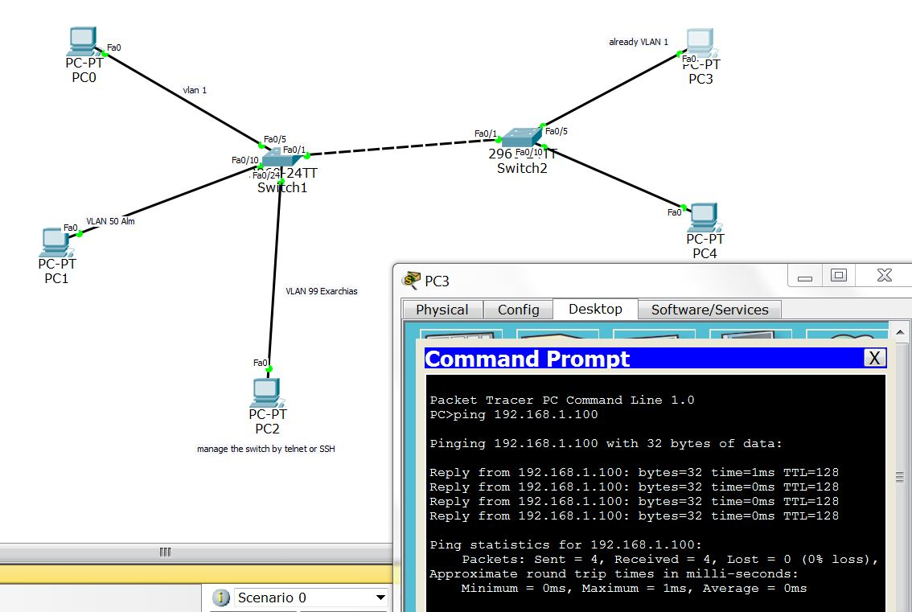

On this part of the assignment we start moving towards trunks but we didn't touch the issue yet. Instead we inserted one switch and two PCs on the network, and after verifying the fact that the default vlan 1 assigns itself automatically to every switch as by default, we revisit briefly the method of connecting a custom VLAN between two switches by inserting one more cable. But as the speaker pointed out this method is wasteful so we prefer to do trunks, which we will talk about on the next video/assignment.

By the way it is worth to mention that I found a cisco packet tracer's bug that is making my life bit more difficult than usual.when I am opening a project with a switch that already has configured entities, (interface, port, vlan etc), then when you are trying to access the CLI you have difficulties to do anything, and you have to access something through the graphical interface and after that to return out of the entity that you choose through exit on the CLI, (it sounds complicated because it is. The CLI of the switch going in to an non existent entity, and it doesn't know how to go out again).

The main point of the assignment is that we can use telnet to access and do stuff to the Switch if we have the IP, (and the password in order to have privileged access). And the how to configure telnet and password.

The command to enable secret password is:
conf f
int fa0/24
enable secret <PASSWORD>

And that was the new thing that we did in this assignment. Otherwise the Insertion of:

PC 3 192.168.1.101/24 fa0/05
and
PC 4 192.168.1.101/24 fa0/10

plus the talk about why things are the way they are, (for example why the VLAN 1 connects automatically to every server), was the main body of the video.

